## **Lab_Day-2 ANP-C9180 (Operators)**

**1. Calculate the multiplication and sum of two numbers .**

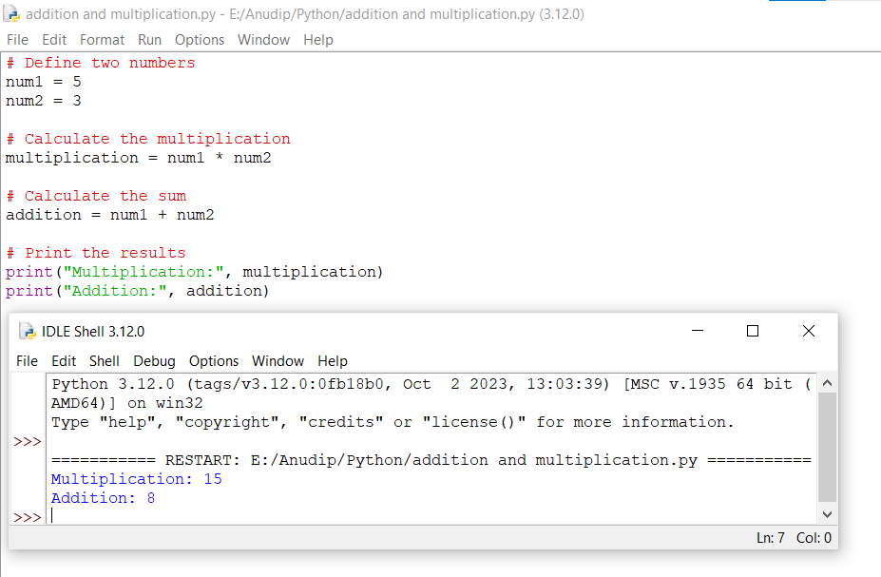

**2. Declare two variables and print which variable is largest using ternary operators .**

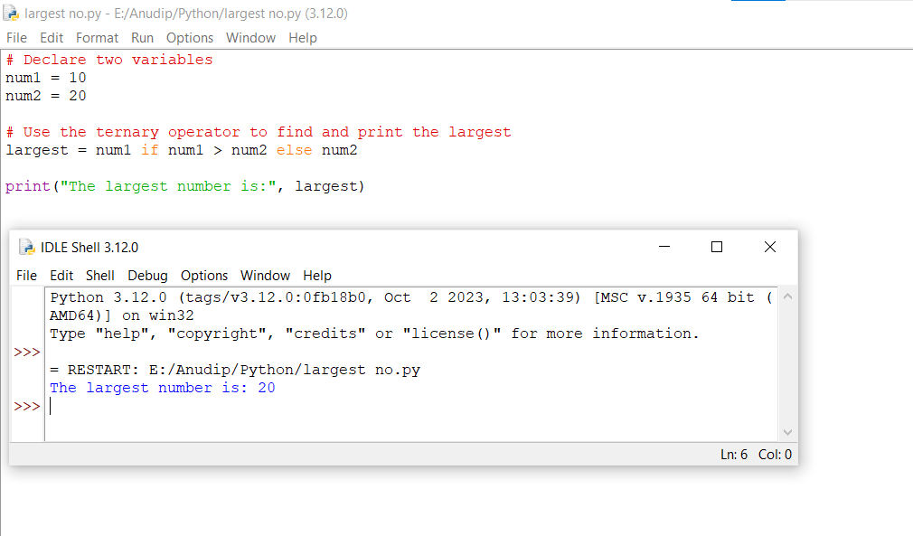

**3. Python program to convert the temperature in degree centigrade to Fahrenheit.**

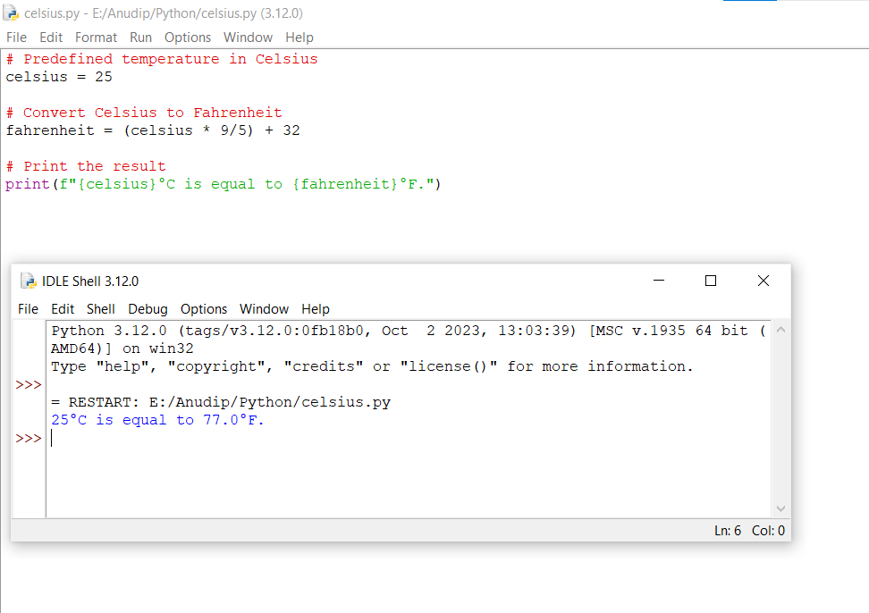

**4. Python program to find the area of a triangle whose sides are given.**

